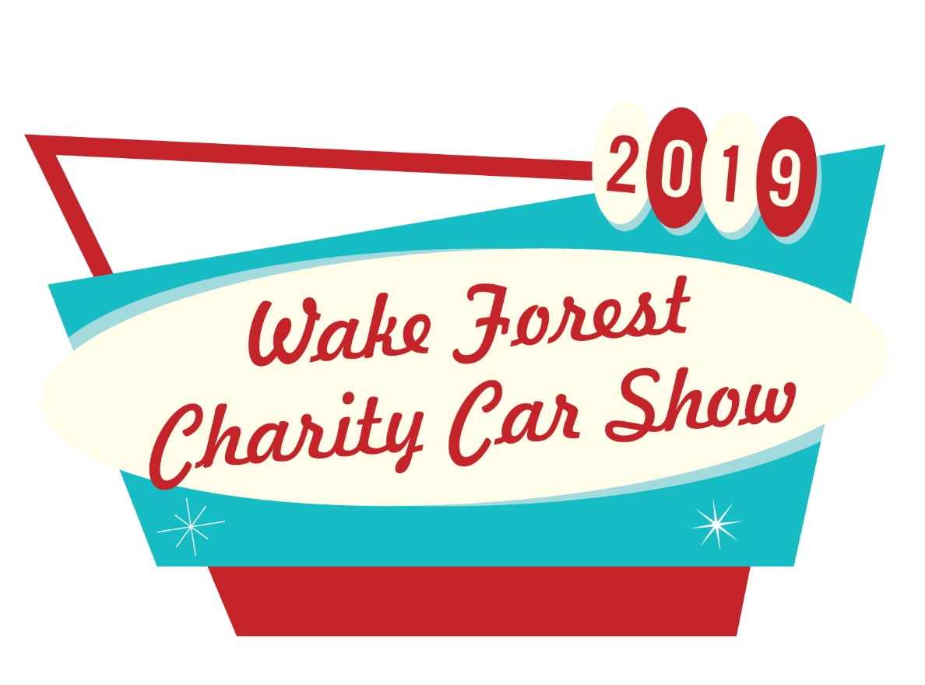

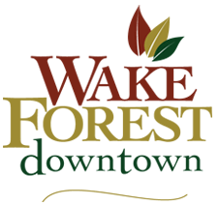

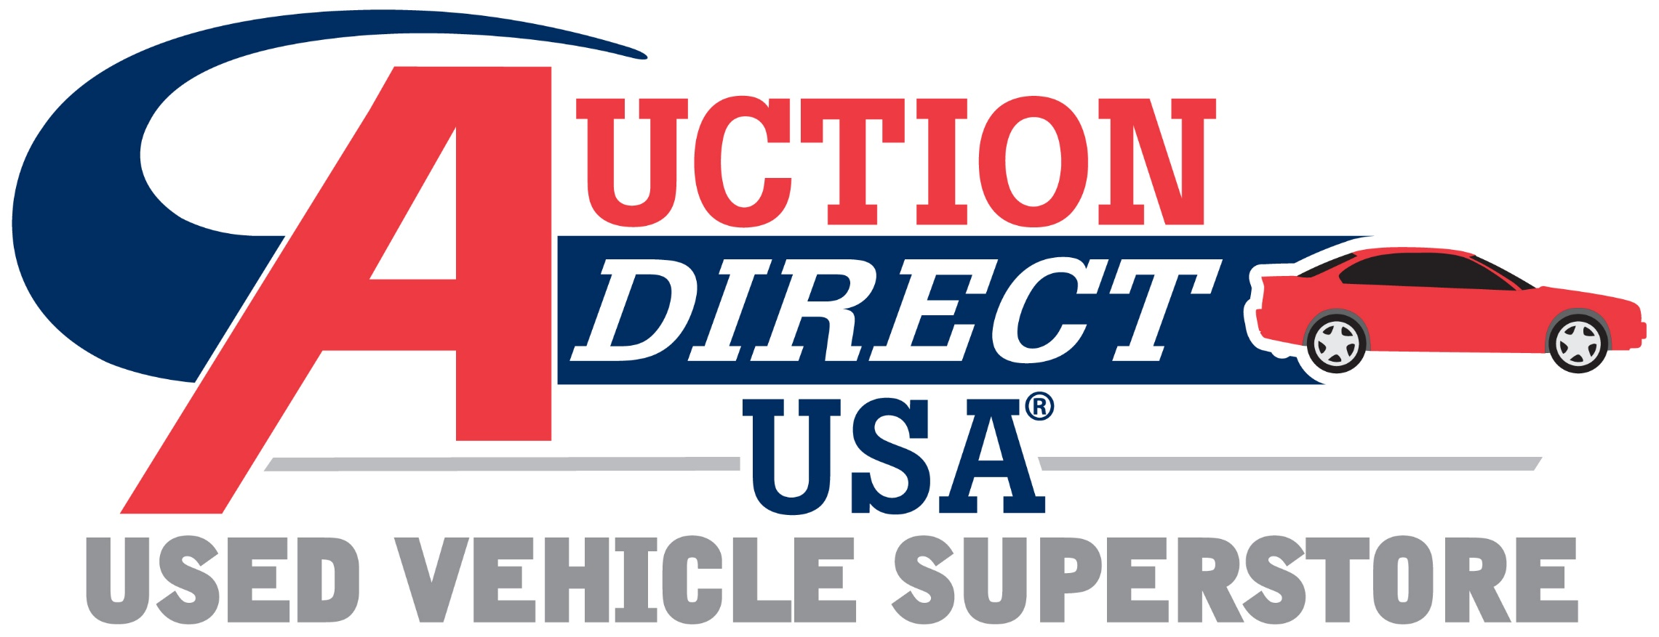

Grand Sponsor, Auction Direct USA
Saturday, June 15, 2019 | 9:00 am-2:00 pm
Downtown Wake Forest
All Proceeds Benefit Local Nonprofit Groups

Sponsorship Opportunities (Please check your chosen level and complete reverse side of form)
□ Grand Sponsor - $2500.00 (Limited to one) SOLD
- Includes all Platinum Sponsor benefits, PLUS
- Grand Sponsor title with top marquis position on website, social media, printed materials and signage
- Blog post on Wake Forest Downtown, Inc. (WFD) website about your sponsorship with link to your website.
- Sponsor name and business logo, with link to your website, will be added to the WFD website on both the home page and the event page, once payment and high-resolution logo are received. Your logo will remain on the home page of the website a minimum of six months from date of payment.
- WFD will feature cover photo on Facebook highlighting event with grand sponsor listed for a minimum of two weeks prior to event and one week after.
- WFD will create a Charity Car Show event on Facebook at least 60 days prior to the event date and invite you as a co-host.
□ Platinum Sponsor - $1000.00
- Includes all Gold Sponsor benefits, PLUS
- Prime booth location where you can sell, promote and/or conduct demos
- Company name listed on website event page with logo and link to your webpage
- Recognition as Platinum Sponsor in all promotions and print materials*
- Recognition on WFD social media platforms three times
□ Gold Sponsor - $500.00
- Sponsor name listed on Thank You Ad in local publication
- Recognition on WFD social media platforms two times
- Sponsor listed on promotional flier
- Sponsor recognition announced during car show activities
- Listed on Sponsor Thank You Poster at the event
□ Silver Sponsor - $250.00
- Sponsor name listed on Thank You Ad in local publication
- Recognition on WFD social media platforms one time
- Listed on Sponsor Thank You poster at the event
□ Bronze Sponsor - $100.00
- Recognition on WFD social media platforms one time
- Listed on Sponsor Thank You poster at the event

*Payment and logo must be received at least 30 days prior to event for inclusion on website and/or printed materials per terms of sponsor benefits

Company Name: _
Contact Name: Email: _____________________________________
Address: Street________________________________ _____________________________________ _
City State ZIP ______________________
Phone: _____________________________
Checks should be made payable to: Wake Forest Downtown, Inc. Please return your completed form and check to any Charity Car Show Committee member or mail to:
Jennifer Herbert
c/o Wake Forest Downtown, Inc.
301 S. Brooks St.
Wake Forest, NC 27587

For questions, please contact Charity Car Show Event Chair, Dawn Nakash, at dawn@wakeforestdowntown.com or 732-606-7220.
Wake Forest Downtown, Inc., is a 501(c)(3) Non-profit. Our Tax ID # is 56-1487206

