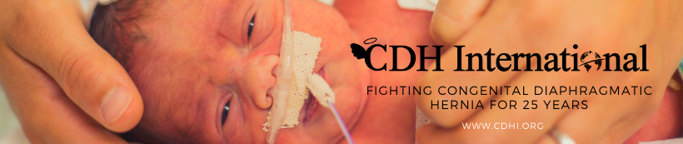

Executive Board Member Application

Instructions: Please fill out the following application, save and email to Dawn Ireland at dawn.ireland@cdhi.org or print and mail to: CDH International, 3650 Rogers Rd #290, Wake Forest, NC 27587, UAS. Any questions can be directed to Ms. Ireland at the above email address. Please review our website at www.cdhi.org for more information about the organization.

Name
Mailing Address

Email Address
Home Phone Number
Cell Phone Number
Work Phone Number
Best Number to be Reached
Home Cell Work
Employer
Title
Type of Business

Work Address

Summarize your experience and/or interest in the organization.

Please list boards and committees on which you currently serve or have served in the past. (Business, nonprofit, civic, professional, social, etc.)

What skills and knowledge are you willing to bring to our board?
Please indicate your experience in the following areas.

Areas | Very Experienced | Some Experience
Strategic Planning
Board Development
Fundraising
Financial Management and Control
Information Technology
Special Events
Communication, Public and Media Relations
Program Planning and Evaluation
Public Speaking
Writing or Journalism
Nonprofit experience
Other Skills (List Below)

What do you hope to gain from a board position?

How do you feel CDH International would benefit from your involvement on the board?

Please list two references that we may contact in relation to your interest in becoming a board member or attach a letter from a current board member.

Name
Phone Number
Relationship
Name
Phone Number
Relationship

Applicant Signature
Date

Please note that if accepted you are agreeing to attend the monthly Board Meetings and you will also agree to sign the Board Member Duties and Responsibilities page which are included for you to read.

Thank you for considering lending your expertise to our organization. We will contact you shortly to discuss the application further.

FOR BOARD USE ONLY:
Application reviewed by:
Date:
Comments:

Approved Declined Withdrawn

BOARD MEMBER DUTIES AND RESPONSIBLITIES

1. Uphold mission and purpose. It is the Board’s responsibility to review and uphold a statement of mission and purpose that articulates CDH International’s goals, means and primary constituents served.
2. Raise funds for CDH International. Actively participate in all fundraising events and committees, work with Grant Manager on new sources of funds, network to find contacts for funds and personally give back to the organization in whatever way possible.
3. Select the Executive Director. The Board must reach consensus on the Executive Director’s responsibilities and undertake a careful search to find the most qualified individual for the position.
4. Support and evaluate the Executive Director. The Board should ensure that the Executive Director has the moral and professional support he or she needs to further the goals of CDH International.
5. Ensure effective planning. The Board must actively participate in an overall planning process and assist in implementing and the monitoring the plan’s goals.
6. Monitor and strengthen programs and services. The Board’s responsibility is to determine which programs are consistent with CDH International’s mission and monitor their effectiveness.
7. Protect assets and provide proper financial oversight. The Board must assist in developing the annual budget and ensuring that proper financial controls are in place.
8. Build a competent board. All Boards have the responsibility to articulate prerequisites for candidates, orient new members, and periodically and comprehensively evaluate their own performance. Attendance at meetings is mandatory as well as attendance at the Annual Board Retreat and Quarterly In Person Membership Meetings.
9. Ensure legal and ethical integrity. The Board is ultimately responsible for adherence to legal standards and ethical norms.
10. Enhance CDH International’s public standing. The Board should clearly articulate the mission, accomplishments and goals to the public and garner support from the community.

If accepted as a board member or officer of CDH International I agree to:

Duty of Care
Each Board member owes the duty to exercise reasonable care when he or she makes a decision as a steward of CDH International.

Duty of Loyalty
The duty of loyalty is a standard of faithfulness: a Board member must give undivided allegiance when making decisions affecting CDH International. This means that a Board member can never use information obtained as a member for personal gain, but must act in the best interests of CDH International.

Duty of Obedience
The duty of obedience requires Board members to be faithful to CDH International’s mission. They are not permitted to act in a way that is inconsistent with the central goals of CDH International. A basis for this rule lies in the public’s trust that CDH International will manage donated funds to fulfill CDH International’s mission.

Once accepted as a Board member, I agree that I have read and understand the terms of the above Duties and Responsibilities as well as CDH International bylaws.

Signature Date

Term Dates

